Fatima Jinnah Women University

*Department of Software Engineering*



LAB #03

Part-II

**SUBJECT: DATABASE SYSTEM**

**SUBMITTED TO: SIR SHOAIB**

**SUBMITTED BY: UMBER QASIM**

**REGISTRATION NO: 2023-BSE-066**

**CLASS: BSSE IV-B**

**To view that which tables are accessed to the user which will help in query.**

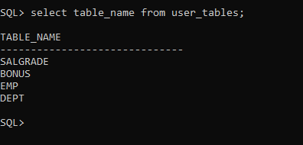

**Describing Table Schema:**

To see the schema of the table, type the following query.

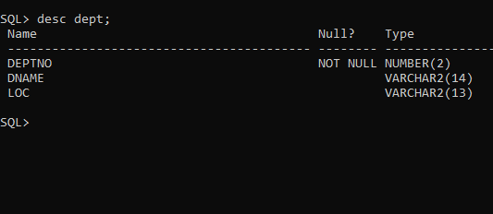

This output gives the attribute name, specify this attribute is null or not and also display the data type of the attribute

**Selecting all Columns:**

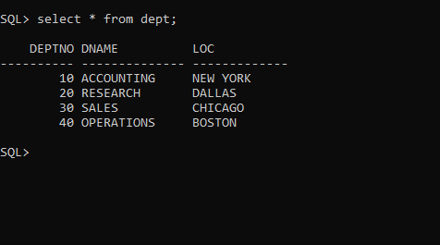

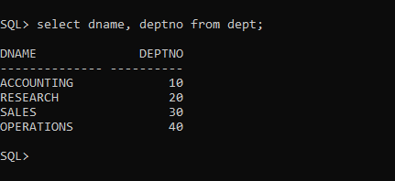

The output is identical because only the format of the statement changed. Now that you have

established control over the order of the columns, you will be able to specify which columns you want to see.

**Selecting Individual Columns**

Suppose you do not want to see every column in the database. You used SELECT * to find out what information was available, and now you want to concentrate on the check number and the amount. You type

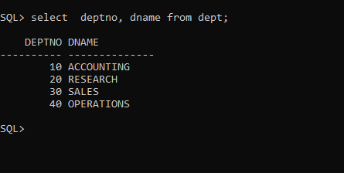

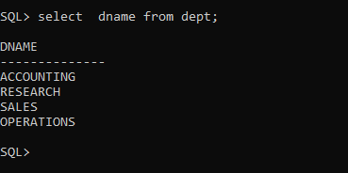

**Queries with Distinction**

If you look at the original table,EMP, you see that some of the data repeats. For example, if you looked at the salary column using

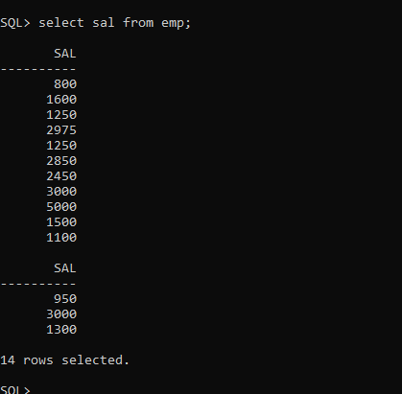

Notice that the amount 1250, 3000 is repeated. What if you wanted to see how many different

amounts were in this column? Try this:

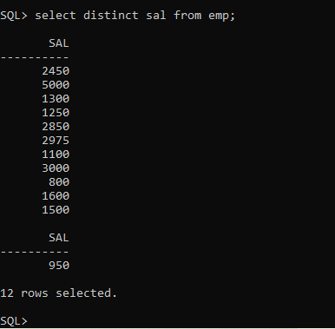

Notice that only twelve rows are selected. Because you specified DISTINCT, only one instance of the duplicated data is shown, which means that one less row is returned. ALL is a keyword that is implied in the basic SELECT statement. You almost never see ALL because SELECT &lt;Table&gt; and SELECT ALL &lt;Table&gt; have the same result.

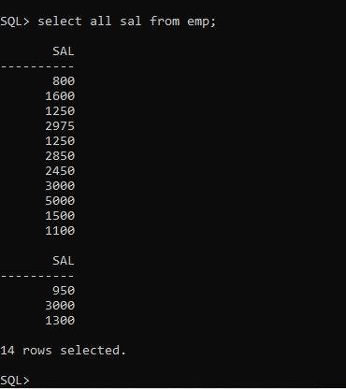

It is the same as a SELECT &lt;Column&gt;.

**The WHERE Clause**

The syntax of the WHERE clause is

**SYNTAX:**

WHERE &lt;SEARCH CONDITION&gt;

SELECT, FROM, and WHERE are the three most frequently used clauses in SQL. WHERE

simply causes your queries to be more selective. Without the WHERE clause, the most useful

thing you could do with a query is display all records in the selected table(s). For example:

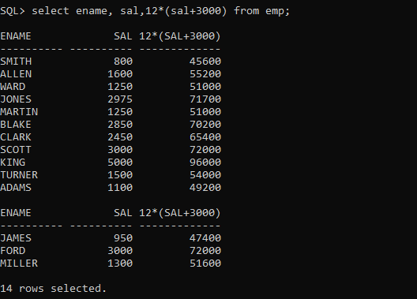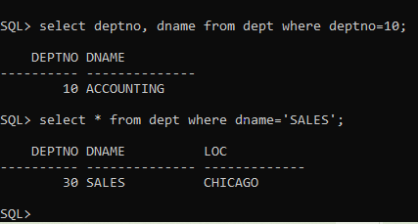

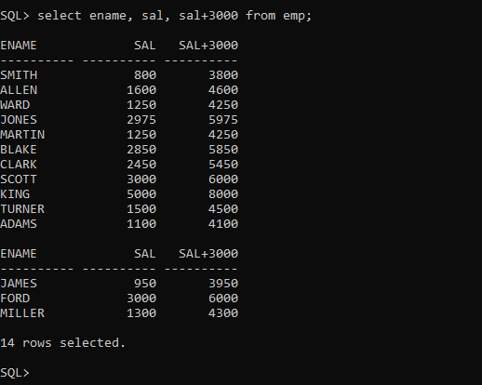

In the above query, employee name, their original salary and salary plus increment of 3000 is

displayed

**Defining Column Alias:**

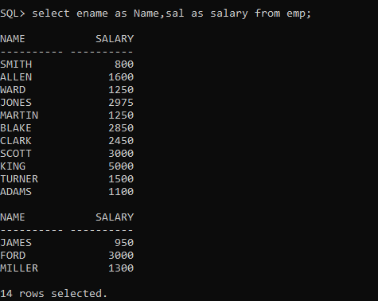A column alias renames a column heading. It is useful with calculations immediately follows the column name (There can also be the optional AS keyword between the column name and alias.) It requires double quotation marks if it contains spaces or special characters or if it is case- sensitive

**Concatenation Operator:**

A concatenation operator links columns or character strings to other columns. It is represented by two vertical bars (||). Results creates a resultant column that is a character expression

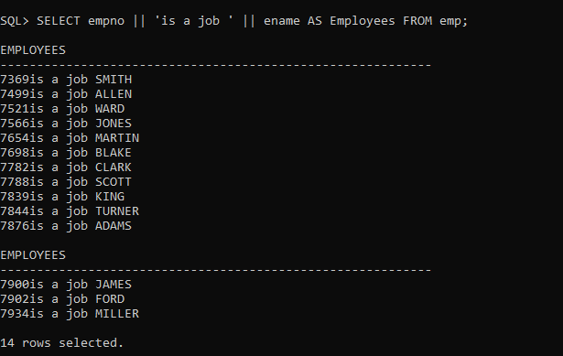

**Literal String:**

A literal is a character, a number, or a date that is included in the SELECT statement. Date and character literal values must be enclosed by single quotation marks. Each character string is output once for each row returned.

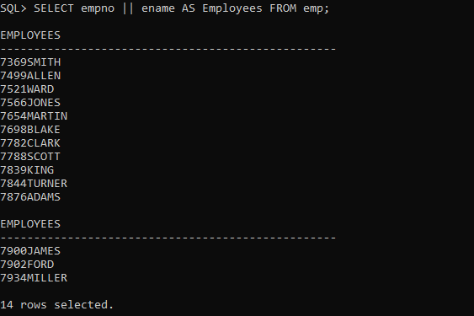

***LAB TASKS:***

**Q1:**

Both queries return the same output because SQL is case-insensitive for keywords and object names (unless created with double quotes).

**Q2:**

**a. Select \***

The query is incomplete because it does not specify a table name

**b. Select * from emp**

the semicolon (;) is missing at the end in SQL*Plus, so execution doesn’t complete.

**c. Select empno ename FROM emp;**

There should be a comma , between column names.

**Q3: Which of the following SQL statements will work?**

a. The query is valid (as long as salgrade table exists).

b.This is also valid.

c.Missing semicolon ; at the end.

**Q4:**

1. Missing comma , between ename and Sal
2. Incorrect multiplication syntax (Sal X 12 should be sal * 12)
3. Missing alias keyword AS before "ANNUAL SALARY"
4. Missing semicolon ; at the end

**Q5.**

**Show the structure of the emp table. Select all data from the table.**

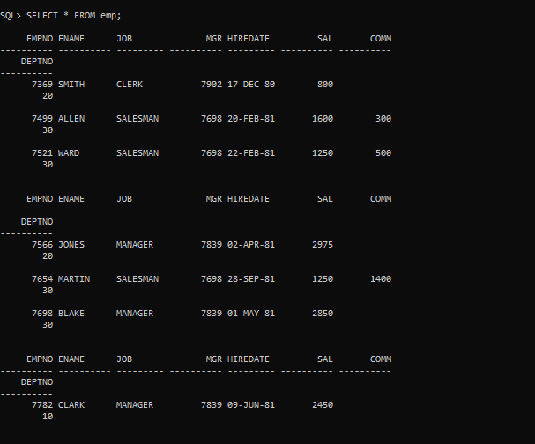

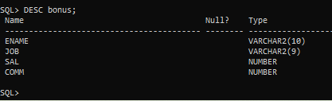**Q6: Show the structure of the bonus table. Select all data from the table**

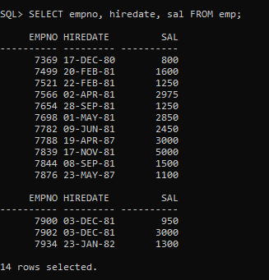**Q7: Create a query to display the empno, hiredate, salary from the employee table**

**Q8: Create a query to display the unique manager id from the employee table**

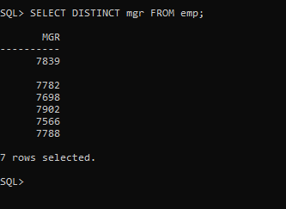

**Q9: Create a query to display the empno, hiredate, salary and rename column as Emp #, Joining Date, Salary from the employee table**

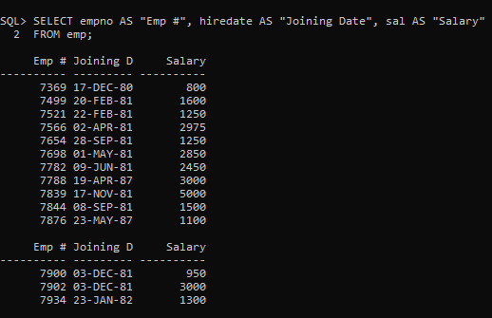

**Q10: Create a query to display all the data from the emp table. Separate each column by comma**

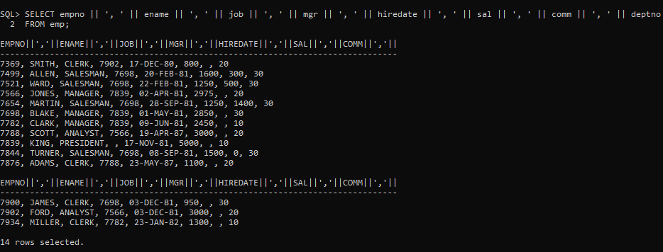

**Q11: Create a query that display the salary of employee with increment of 10%.**

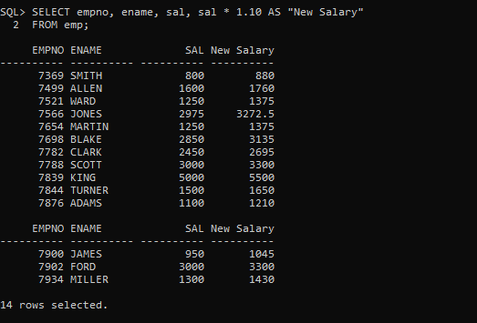

**Q12: Display the employee name concatenated with the job tile and hires date and names the column “Employee Details”**

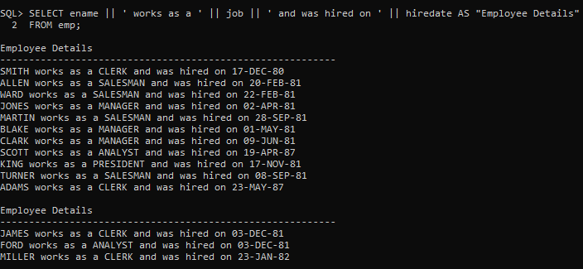

**Q13: Create a query that display the employee details of all employees whose designation is “CLERK”**

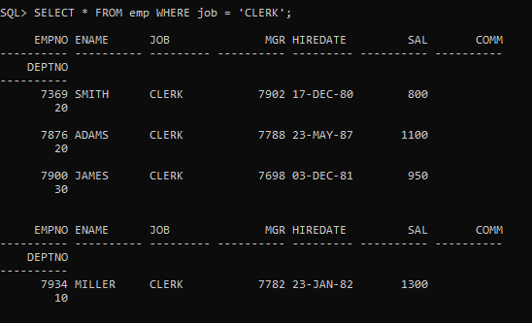

**Q14:** **Create a query that display the location of the department “OPERATIONS”**

